SMART PANTRY MANAGER

Student Name: Nephawe Student Number: 402413319
Module: Mobile App Development 700
Institution: Richfield Graduate Institute of Technology
Programming Language: Java Database: SQLite

Contents
SMART PANTRY MANAGER 1
1. INTRODUCTION 2
2. AIM OF THE PROJECT 2
3. SYSTEM DESIGN 3
4. DATABASE DESIGN 3
5. APPLICATION SCREENSHOTS 3
5.1 Pantry List Screen 3
5.2 Add Ingredient Screen 3
5.3 Edit Ingredient Screen 4
5.4 Delete Ingredient Function 4
5.5 Suggested Recipes Screen 6
5.6 Recipe Detail Screen 6
5.7 No Matching Recipes 7
5.8 Settings Screen 7
7.1 Recipe Matching Test 8
6 CHALLENGES AND SOLUTIONS 9
6.1 Database Challenge 9
6.2 Recipe Matching Challenge 9
6.3 Application Design Challenge 9
7. CONCLUSION 9
8. REFERENCES 9

1. INTRODUCTION
For this project, I developed an Android application called Smart Pantry Manager.
You find that The app helps users manage the food ingredients they have at home. The other thing is that It also suggests recipes using the ingredients available.

2. AIM OF THE PROJECT
You find that the aim of my project is to make managing food ingredients easier.
Users can add, edit, delete and view their ingredients.
They can also find recipes that match their available food.

3. SYSTEM DESIGN
The application has different screens for different tasks.
Users can move between the pantry, recipes and settings screens. Each screen helps users perform a specific function.

4. DATABASE DESIGN
I used SQLite to store the information in my application.
The database saves pantry ingredients and recipe information. It helps the app retrieve saved information when needed.

5. APPLICATION SCREENSHOTS

5.1 Pantry List Screen
This screen shows the ingredients saved in my application.
Users can check the names and quantities of their ingredients. It helps users know which food is available in their pantry.

Figure 3: Pantry List Screen
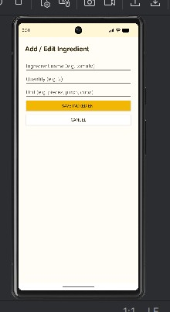

5.2 Add Ingredient Screen
This screen allows users to add new ingredients.
Users enter the ingredient name, quantity and unit.
After saving, the ingredient should appear in the pantry list.

Figure 4: Add Ingredient Screen
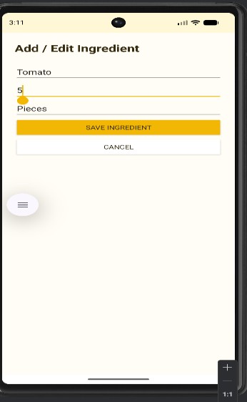

5.3 Edit Ingredient Screen
This function allows users to change ingredient details.
For example, users can update the quantity of an ingredient.
The updated information should be saved in the application.

Figure 5: Edit Ingredient Screen
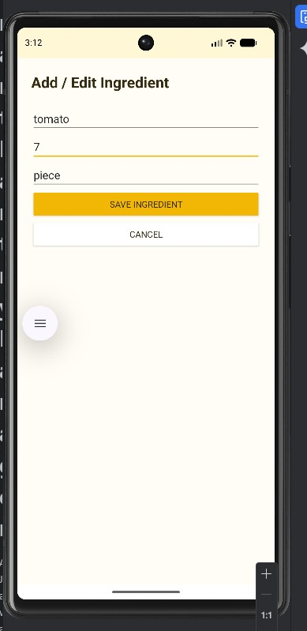

5.4 Delete Ingredient Function
Users can remove ingredients that they no longer need.
The deleted ingredient should disappear from the pantry list.
The app should use the updated ingredients when suggesting recipes.
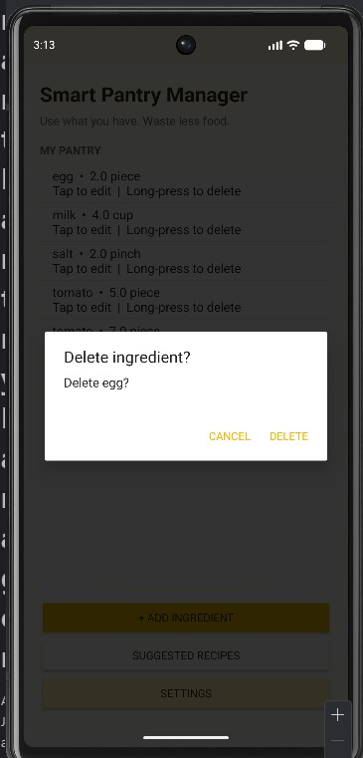
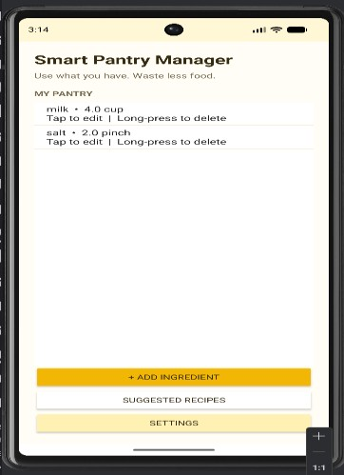

Figure 6: Delete Ingredient Test
[INSERT A SCREENSHOT SHOWING THE INGREDIENT REMOVED HERE]

5.5 Suggested Recipes Screen
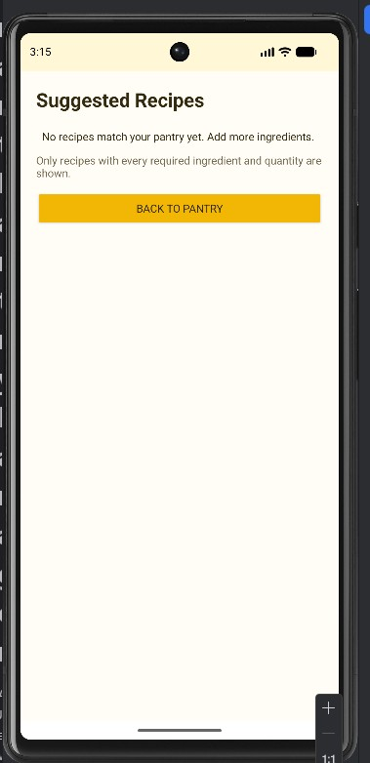
This screen shows recipes that match the pantry ingredients.
The app checks that all required ingredients are available.
It also checks whether the available quantities are enough.

5.6 Recipe Detail Screen
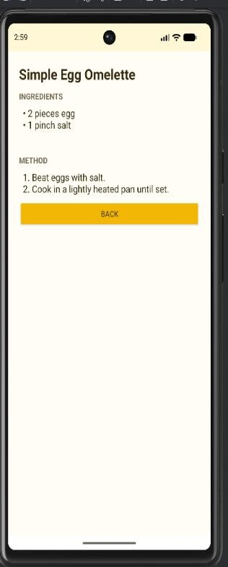
Users can select a recipe to view more information.
The screen displays details about the selected recipe.
This helps users understand which recipe they have chosen.
Figure 8: Recipe Detail Screen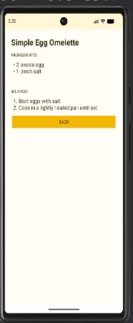

5.7 No Matching Recipes
Sometimes the pantry may not have all the required ingredients.
In this case, the recipe should not appear as a match.
The app should show a message when no recipes match.

Figure 9: No Matching Recipes

5.8 Settings Screen
The Settings screen provides access to the app settings.
Users can open this screen from the application.
It helps users access the available settings options.

Figure 10: Settings Screen
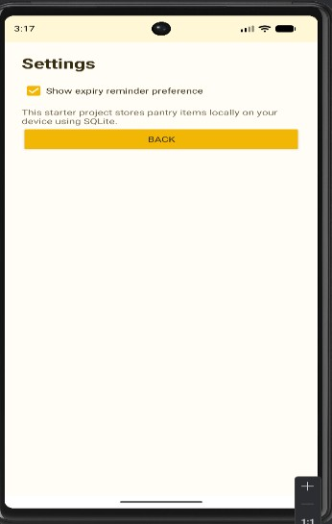

7.1 Recipe Matching Test
The Tomato Egg Scramble recipe requires two tomatoes, two eggs and one pinch of salt.
The recipe should appear when all the required ingredients and quantities are available. If one required ingredient is missing or insufficient, the recipe should disappear.
Figure 15: Recipe Matching Test
Figure 16: Recipe After Removing an Ingredient

6 CHALLENGES AND SOLUTIONS

6.1 Database Challenge
One challenge was connecting the application to the database.
I needed to understand how the app saves ingredient information. I worked on the database code to manage the information.

6.2 Recipe Matching Challenge
Another challenge was checking the ingredients required for recipes.
The app needs to check both the ingredients and their quantities.
This helps prevent recipes from appearing when ingredients are missing.

6.3 Application Design Challenge
I also needed to organise the different application screens.
Each screen had to allow users to perform a specific task.
I used separate activities to organise the main functions.

7. CONCLUSION
This project helped me learn more about Android application development.
I learned how to use Java, SQLite and different application screens.
I also learned how to manage ingredients and check recipe matches.

8. REFERENCES
Android Developers. (n.d.) Android Developers Documentation. Available at: https://developer.android.com/
Oracle. (n.d.) Java Documentation. Available at: https://docs.oracle.com/en/java/
SQLite. (n.d.) SQLite Documentation. Available at: https://www.sqlite.org/docs.html

